Specialist Mathematics Units 3 and 4.

Take Home Task: Wheel of Steel Due: Tuesday 1st May.

Validation Test: Thursday 3rd May. You will be permitted to bring in your take-home component and calculator.

Introduction

The Wheel of Steel is a vast piece of revolving circus apparatus with revolving wheels at either end. Highly trained artists perform both inside and outside the wheel whilst maintaining balance and grace as the wheel turns.

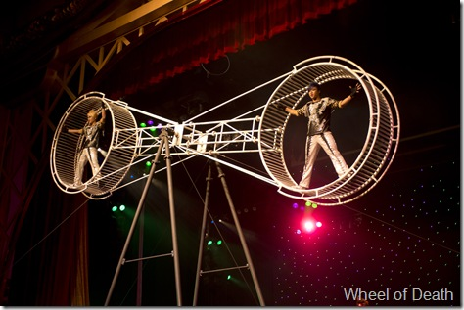

The Wheel of Steel can be modelled by the diagram below:

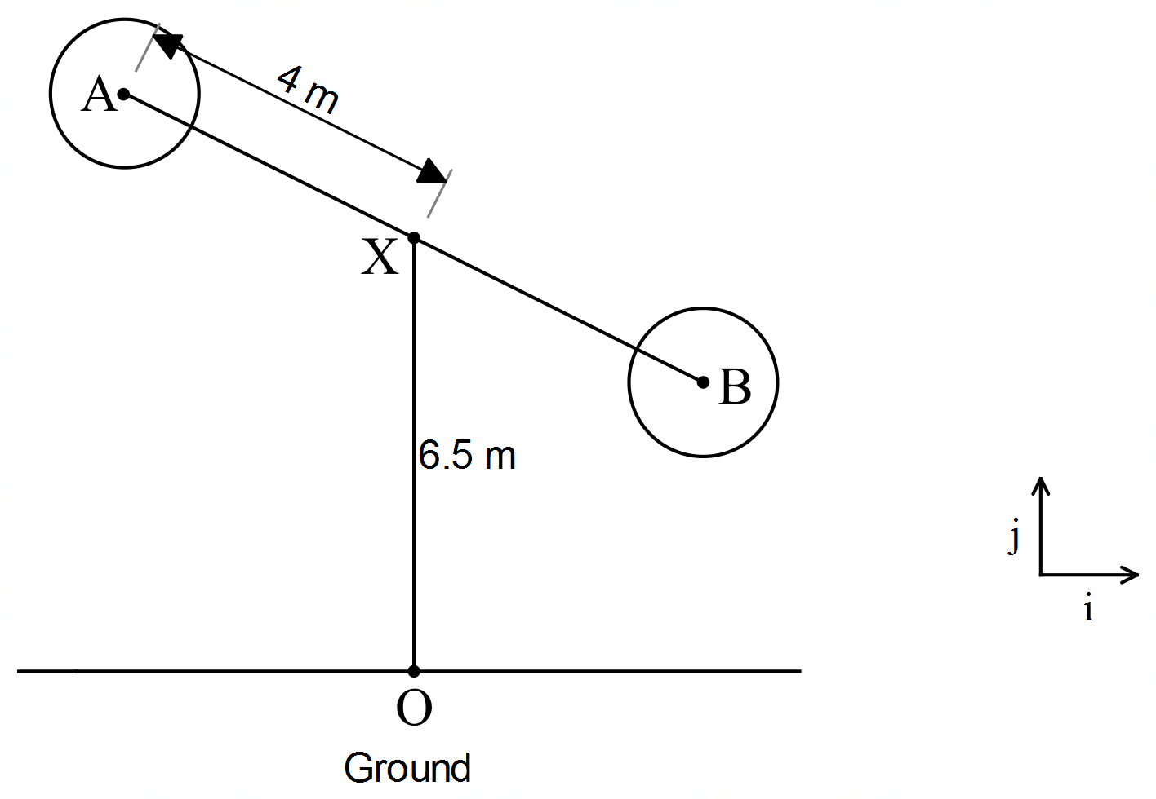

The central rod *AB* revolves about *X*. Mini wheels are rotating about *A* and *B*.

The vector equation describing the motion of *A* *t* minutes after the Wheel of Steel starts is

***r*** (*t*) = 4 sin (2π t) ***i*** + (–4cos (2π t) + 6.5) ***j*** where all distances are measured in metres.

1. Where is *A* when the ride starts? Find the position vector of *A* for *t* = 0..25, 0.5, 0.75

In which direction is *A* rotating and how long does it take for *A* to complete one

revolution?

1. In the equation ***r*** (*t*) = 4 sin (2π t) ***i*** + (–4cos (2π t) + 6.5) ***j***, explain why:
2. the frequency is 2π
3. the amplitude is 4
4. the coefficient of the the **j** component has “+ 6.5”
5. the **i** component is defined in terms of sine
6. the **j** component is defined in terms of –cosine
7. Find vector equations for the velocity and acceleration of the point *A* at time *t.*Find the speed of *A* at time *t*.
8. Find the cartesian equation of the path of *A* and find the distance *OA* when *t* = 0.25.
9. State the position vector of point *B* at time *t* minutes.
10. State the position vector for the motion of *A* if when *t* = 0 the position vector of *A* is

4***i*** + 6.5***j*** and *AB* is revolving about *X* in a clockwise direction at the same speed in c.

**Name: ____________________________**

Specialist Mathematics Units 3 and 4

In Class Task: Wheel of Steel Total Marks 35

Time 55 minutes You may have your take home component and classpad.

The motion of the mini wheels are now to be considered.

The mini wheels rotate once every 20 seconds.

The radius of the mini wheel is 1.5 m. The wheel rotates in a

clockwise direction. Initially *V* is vertically below *A.*

*V*

A

***j***

***i***

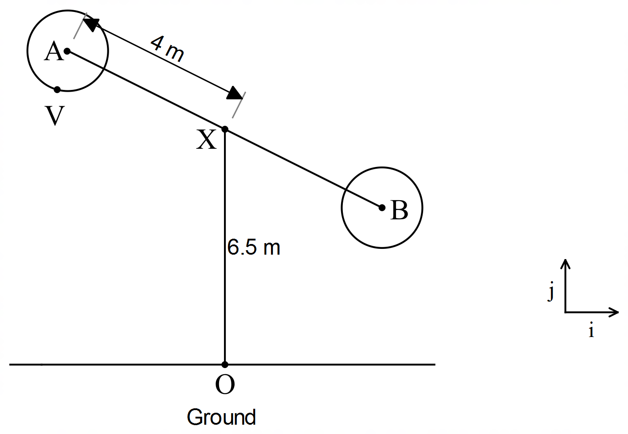

1. State the vector equation describing the motion of *V*, relative to *A* as a function of *t* (*t* is measured in minutes).That is state the vector equation of 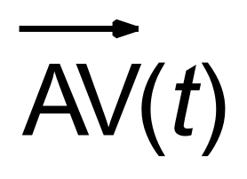 **. (5 marks)**

*Mini wheel rotates once every 20 seconds, therefore 3 revolutions per minute.* ***1 mark***

**

***1 mark*** *frequency of 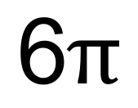*

***1 mark*** *amplitude of 1.5*

***1 mark*** *negative sine for* ***i*** *component*

***1 mark*** *negative cosine for* ***j*** *component*

1. Determine the position vector of *V* relative to *O* at time *t,* that is 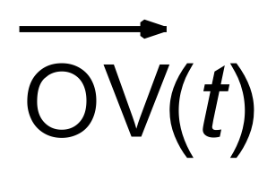 . Where the initial position of *V* is vertically below A and the initial conditions for *A* are as described in the Take Home Section of the investigation, that is  *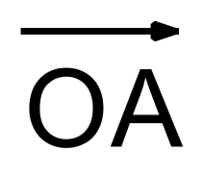(t*) = 4 sin (2π t) ***i*** + (–4cos (2π t) + 6.5) ***j*** **(2 marks)**

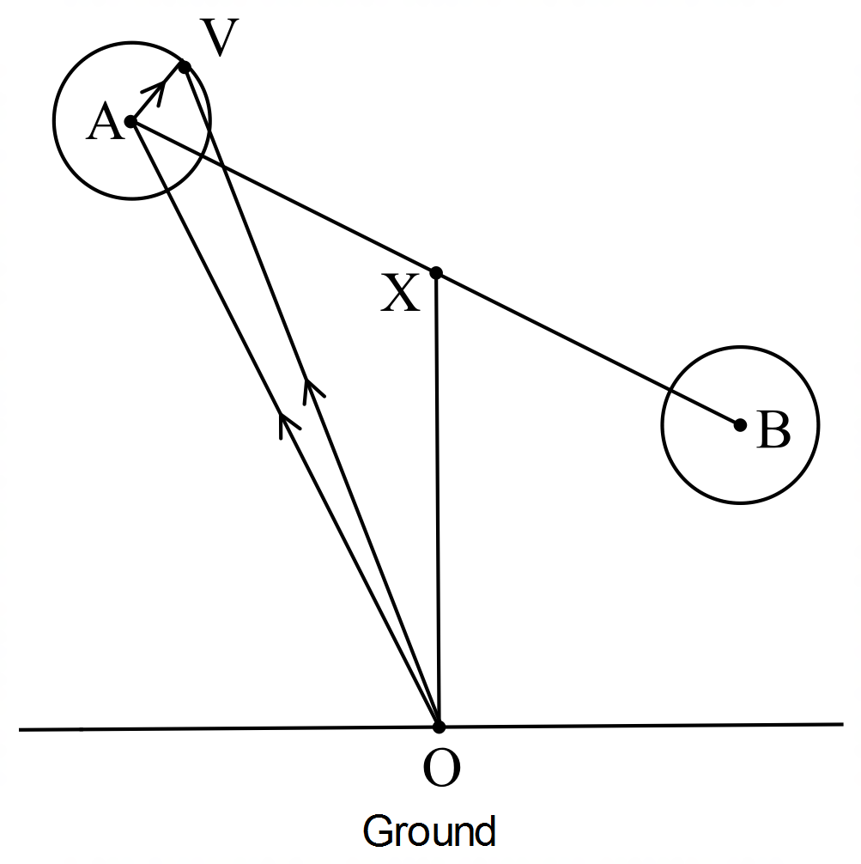

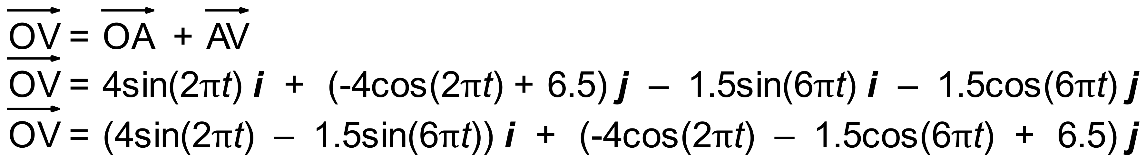

*1* ***mark*** *for* ***i*** *term* ***1 mark*** *for* ***j*** *term*

1. Plot the graph of the path of V and show the direction it is travelling in. **(6 marks)**

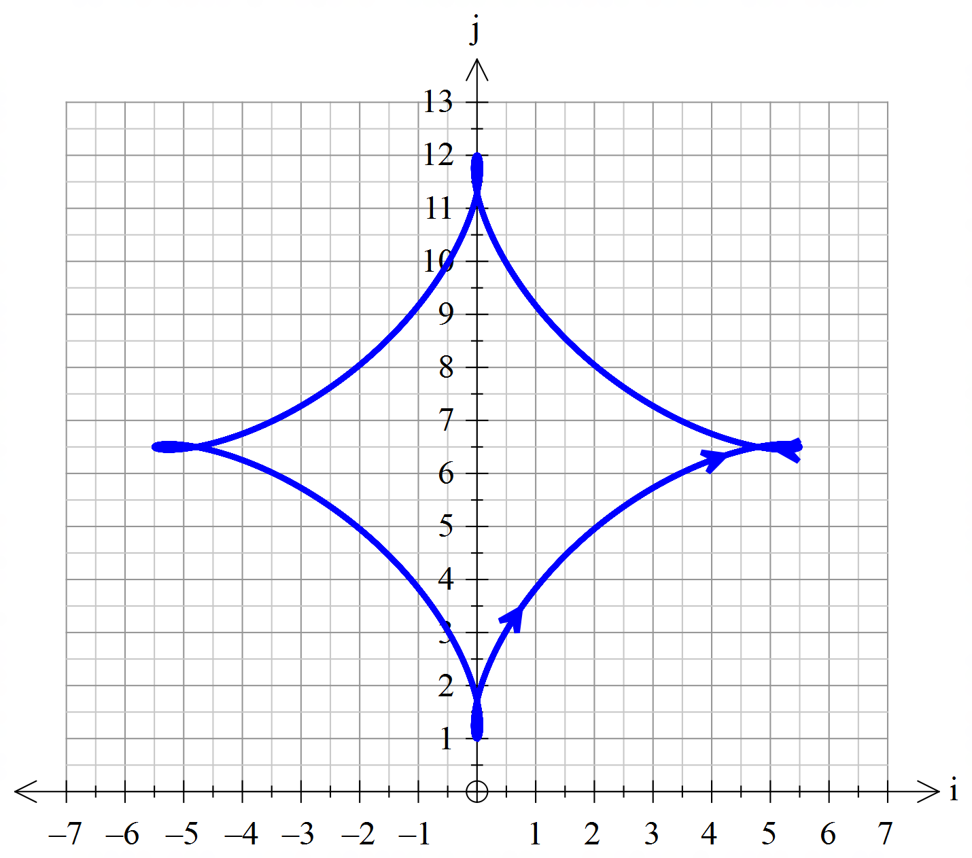

***1 mark*** *for scale*

***1 mark*** *direction*

***4 marks*** *graph (1 per error – should be curve (-1 if straight*)

1. Find the velocity of point *V* as a vector function of *t*. **(4 marks)**



* 🗹 🗹 🗹 ***1 mark*** each derivative

1. Find the speed of point *V* at time *t* and hence find the maximum and minimum speeds of point *V* and the times at which these occur in the first revolution of rod *AB* (exact values required). **(8 marks)**

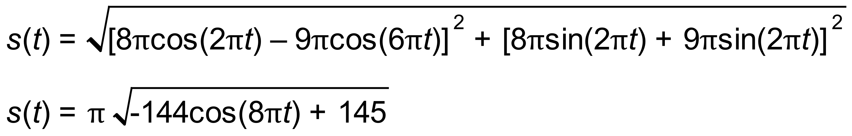

***1 mark***

***1 mark*** *fully simplified*

***1 mark***

***1 mark***

***2 marks*** *(- per error till 0)*

***2 marks*** *(- per error)*

Minimum speed is 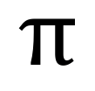 m/min

Maximum speed is 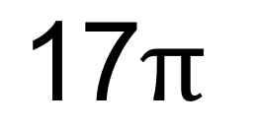 m/min

Minimum speed occurs at 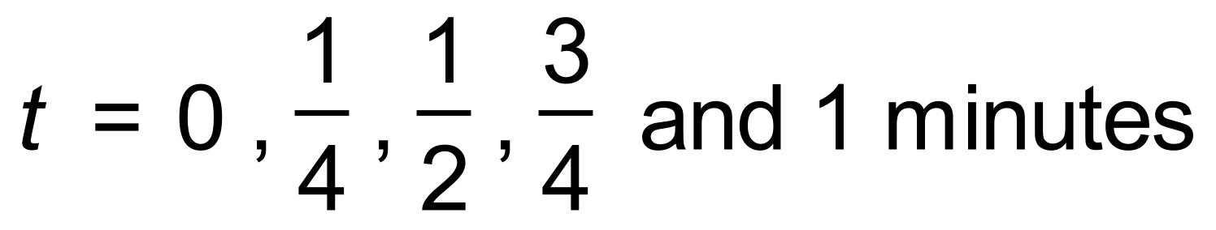

Maximum speed occurs at 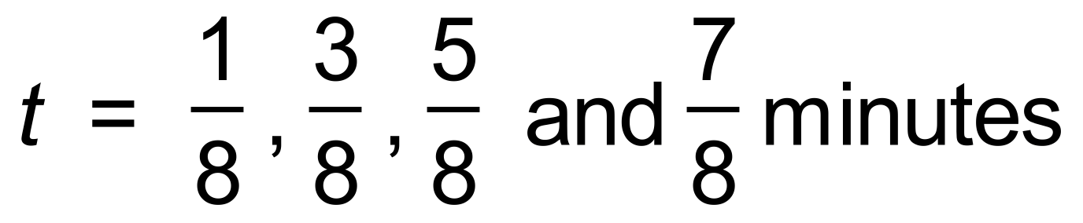

1. Describe the position of point *V* at these times of maximum and minimum speeds. (Hint: it may help to consider a diagram of the Wheel of Steel) **(5 marks)**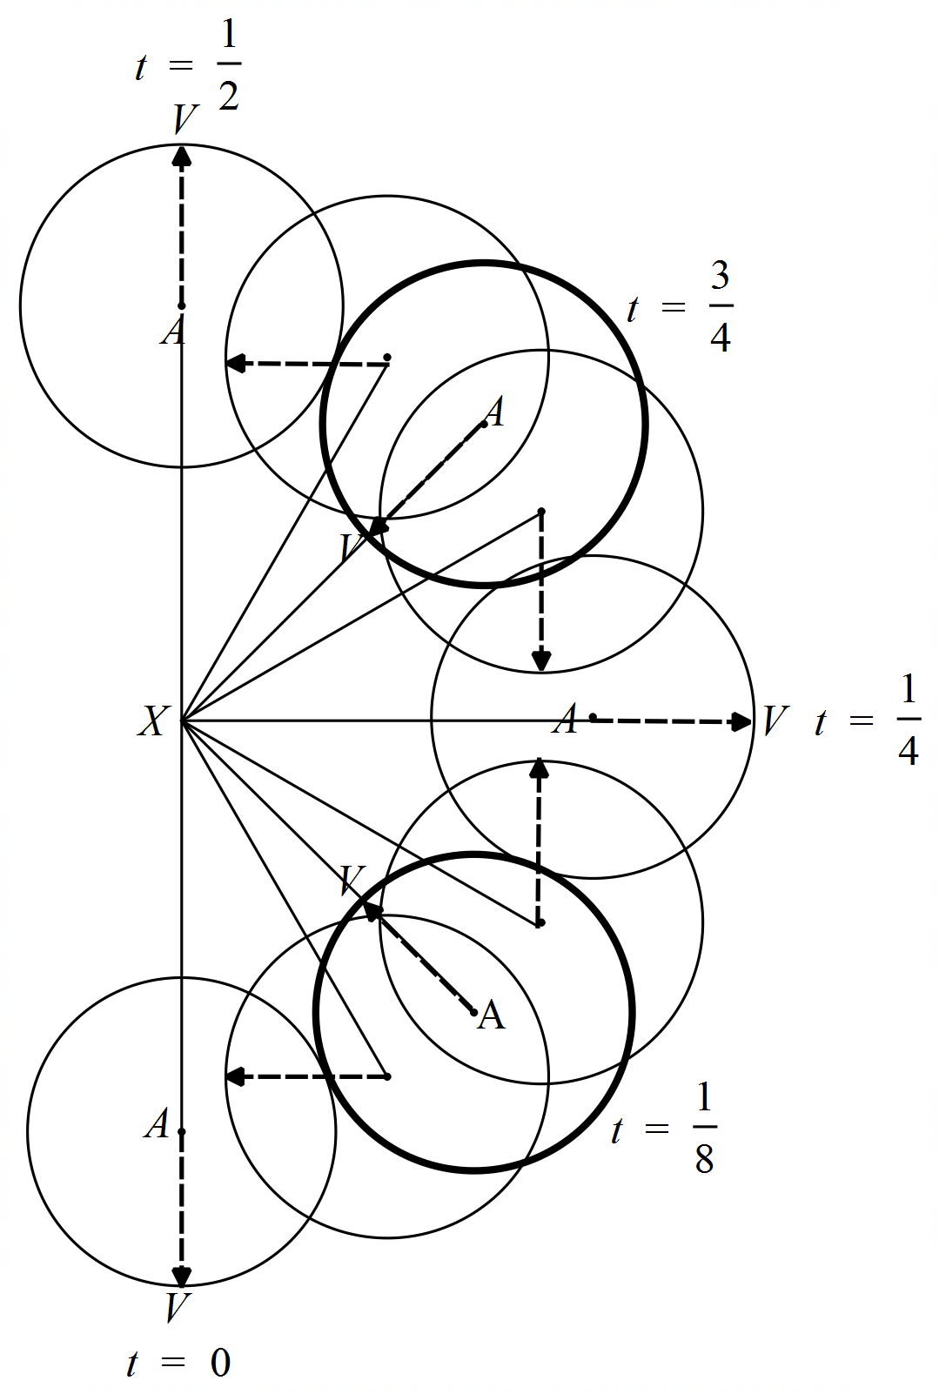

Maximum speed occurs when the vector is pointing is collinear with and pointing in the same direction.

***1 mark*** *for collinear*

***1 mark*** *for same direction*

Minimum speed occurs when the vector is pointing is collinear with and pointing in the opposite direction.

***1 mark*** *for collinear*

***1 mark*** *for opposite direction*

***1 mark*** *for diagram or some aid*

1. Plot the graph of speed against time for 0 ≤ *t* ≤ 1. **(5 marks)**

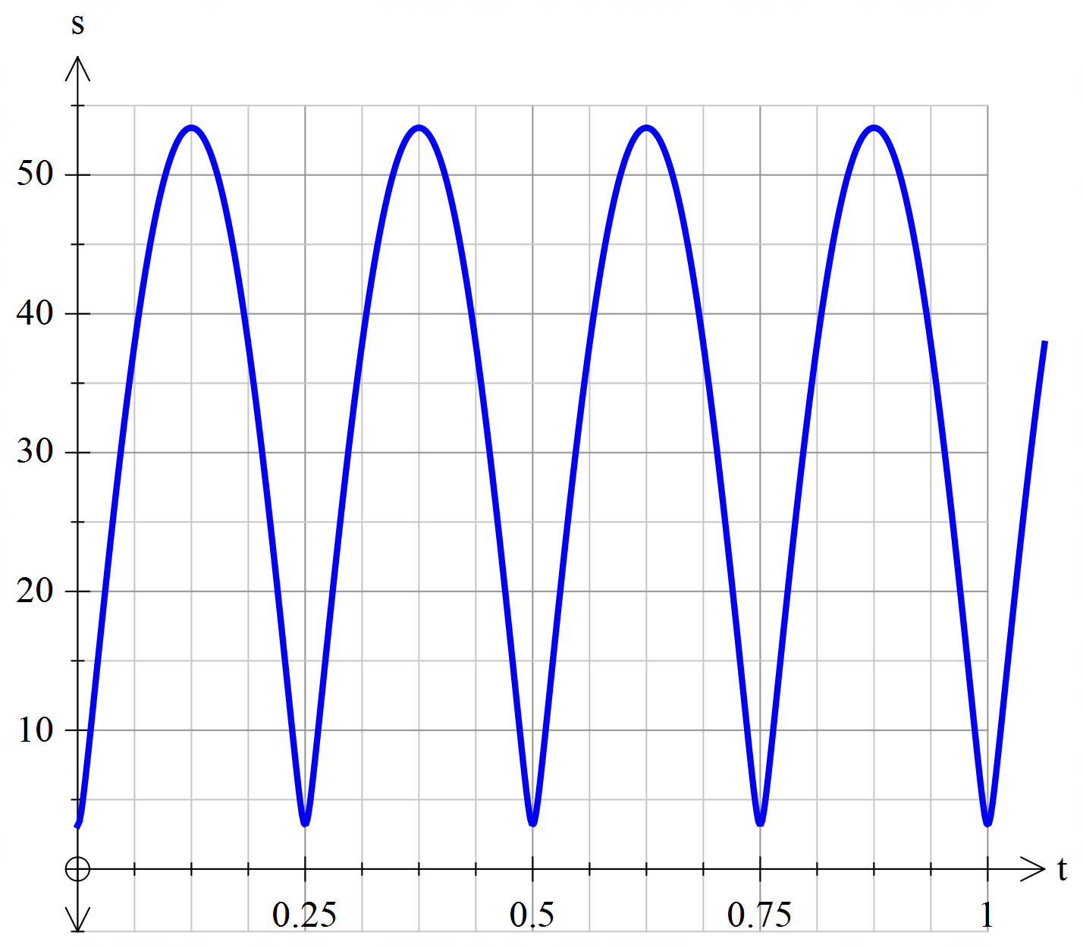

***1 mark*** *for scale*

***1 mark*** *correct min value*

***1 mark*** *correct max value*

***1 mark*** *correct t values where min occurs*

***1 mark*** *correct t values where max occurs*